**Web Application Using Node-Red Service**

**Team ID**:PNT2022TMID48820

**Project Name**:IOT Enabled Smart Farming Application

**Flow1:**

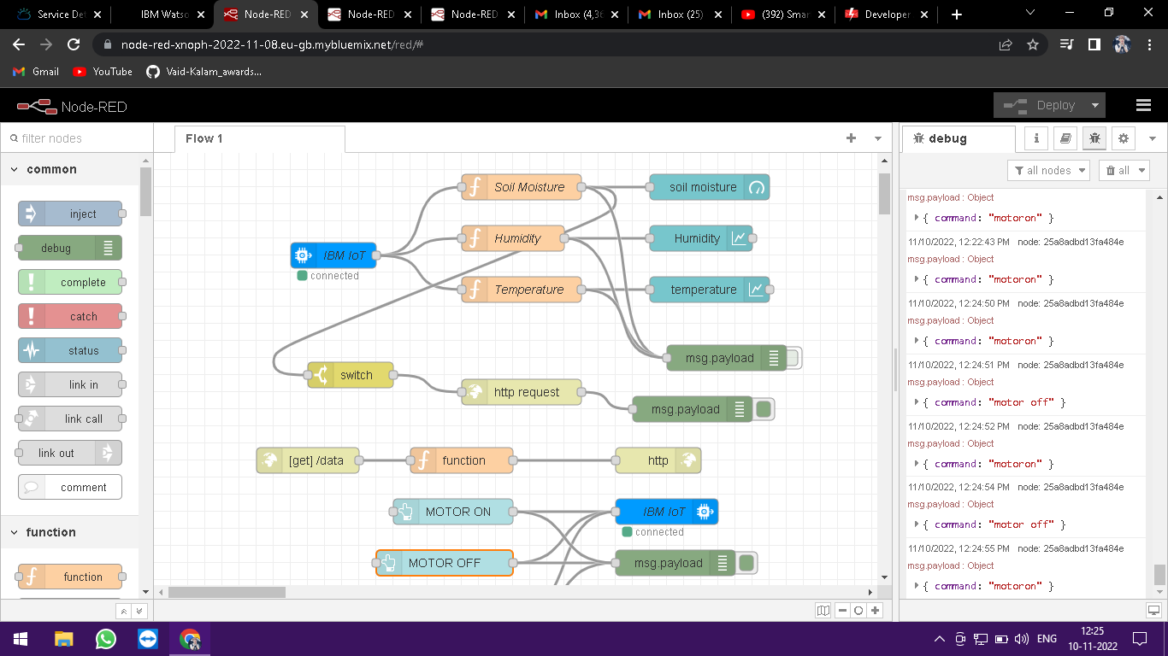

**Flow 2**:

